A116-Eur-South Italic-Kylix-Stemless-Blackware-ca 4th century BCE

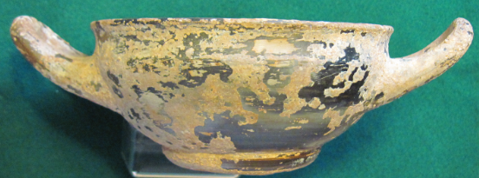 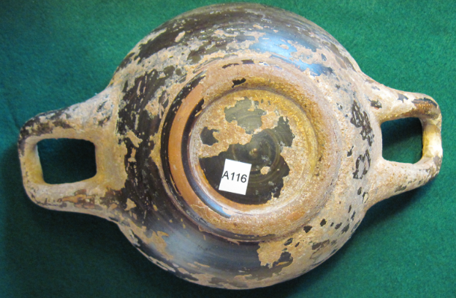 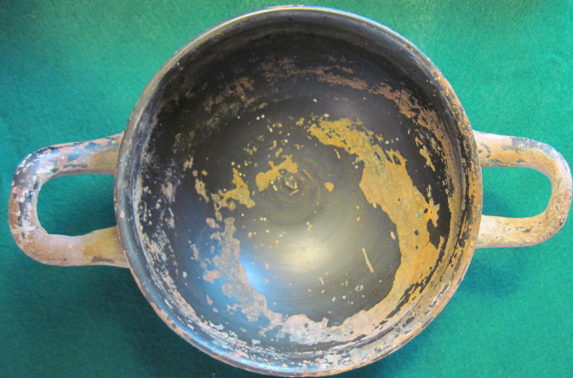

Figs. 1-3. Eur-South Italic-Kylix-Stemless-Blackware-ca 4th century BCE

**Case No.: 4**

**Accession Number: A116**

**Formal Label:** Eur-South Italic-Kylix-Stemless-Blackware-ca 4th century BCE

**Display Description:** Κύλιξ, *kylix*, is cognate with the Latin *calix,* and the English "chalice." **This** kylix is a wine-drinking vessel of the 6th and 5th century BCE. Its broad shallow body with two symmetrical handles enabled drinking while recumbent, as was the case in the Greek *symposia*. Its shallow interior is engraved with a circle on the interior base of the cup, called the [tondo](http://en.wikipedia.org/wiki/Tondo_%28art%29), and was the primary surface for painted decoration in the Black-figure or Red-figure styles which were often designed with this in mind, so that as the drinking proceeded these images would gradually be uncovered surprising or titillating the drinker. This particular twin-handled South Italic Blackware kylix dating to ca. 4th century BCE has a distinctive stemless shape.

**LC Classification:** NK4645

**Date or Time Horizon:** 4th century BCE

**Geographical Area:** southern Italy

**Map:**

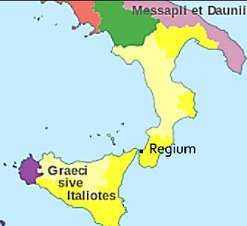

**Fig. 4.** A map of southern Italy in 4th century BCE, showing the Greek alliance area in what is “Magna Gaeca” in the wake of the Latin War. Borders are approximate. Yellow on the map is the Greek South Italic area (Graeci sive Italiotes) from which this particular Blackware kylix originated. By Halibutt (Own work) [CC BY-SA 4.0 (https://creativecommons.org/licenses/by-sa/4.0)]

**GPS Coordinates:** [38°06′41″N 15°39′43″E](https://tools.wmflabs.org/geohack/geohack.php?pagename=Reggio_Calabria&params=38_06_41_N_15_39_43_E_type:city%28200330%29_region:IT-78)

**Cultural Affiliation:** Greek South Italic area

**Medium:** ceramic Blackware

**Dimensions**: Dia 13 cm, 5 1/8 in; H 6 cm, 2.25 in  
**Weight:** 222 g, 7.75 oz

**Provenance:** Greek South Italic area

**Condition:** original

**Discussion:**

For purposes of simplicity the location of the origin of this vessel is placed at Regium (modern Reggio, which was added to the base map) on the mainland of that portion of the Italian peninsula which was so-called “Magna Graeca.” Regium is the oldest city in the region and was an important and flourishing colony of Magna Graecia producing many ceramics including Blackware vessels. Regium is the second oldest Greek colony in southern Italy having been settled by the inhabitants of Chalcis in 743 BCE, and in the 4th century BCE it allied with Athens during the Peloponnesian War.

**References:**

Eberhard, Paul. 1983.*Griechische Vasenmalerei*. Wien: Edition Tusch.

Furtwangler, A. and K. Reichhold. 1902. *Griechische Vasenmalerei: Auswahl hervorragender Vasenbilder / mit Unterstutzung aus dem Thereianos-Fonds der Kgl. Bayerischen Akademie der Wissenschaften herausgegeben von A. Furtwangler und K. Reichhold; nach Furtwanglers tode fortgefuhrt von Friedrich Hauser.* Munchen: Bruckmann.

Kanowski, Maxwell G. 1984. *Containers of Classical Greece.* Saint Lucia: University of Queensland Press, 1984.